|  |  |  |  |  |  |  |
| --- | --- | --- | --- | --- | --- | --- |
| Description: Vertical full colour positive | Safety Bay Senior High School | | | | | |
| **CHEMISTRY UNIT 3 & 4** | | | | | | |
| **Test #4:** | | | | | | |
| **Organic Chemistry** | | | | | | |
|  | | | | | | |
| **NAME:** | | |  | | | |
|  | | |  | | | |
| **Time allowed for this paper** | | | | | | |
| Reading time: | | 5 minutes | | | | |
| Working time: | | 50 minutes | | | | |
|  | | | | | | |
| **Structure of this paper:** | | | | | | |
| Section | | | Number of questions | Marks available | | Marks achieved |
| Section One: Multiple Choice | | | 10 | 10 | |  |
| Section Two: Short Answer | | | 6 | 41 | |  |
|  | | |  | | **Total** | ______ / 51 |

**Section One: Multiple Choice**

1. Which of the following molecules can exhibit geometric *(cis-trans*) isomerism?
2. CH3-CH2-CH=CH-CH3
3. CH2=CH-CH2Br
4. CH2BrCH2Br
5. CH3CH=C(CH3)2
6. A student was given the task of identifying a liquid organic compound that contains only carbon, hydrogen and oxygen. The following tests were carried out:

|  |  |  |
| --- | --- | --- |
|  | **Procedure** | **Result** |
| Test 1 | Some brown Br2(aq) was added to a sample of the compound | A reaction occurred and a colourless product formed |
| Test 2 | Some Na2CO3(s) was added to a sample of the compound | A reaction occurred and a colourless gas was evolved. |

Which structure below matches all the provided observations?

|  |  |
| --- | --- |
|  |  |
|  |  |

1. Which of the following is **least** soluble in water?

1. CH3CH2OH
2. CH3CH2CH2CH2CH2CH2OH
3. CH3COCH3
4. HOCH2CH(OH)CH2OH
5. The systematic or IUPAC name for the following is



1. 2-bromo-2-methylbutanoic acid.
2. 2-ethyl-2-bromopropanoic acid.
3. 3-bromo-3-methylbutanoic acid.
4. cis-3-propanoic acid

1. The ester present in artificial strawberry flavouring is shown below.



The two compounds which were used to chemically prepare this ester were:

1. butanol and ethanoic acid.
2. ethanol and butanoic acid.
3. hexanol and acidified dichromate.
4. hexanoic acid, hexanol and a suitable catalyst.
5. How many isomers are there with the molecular formula C2H2Br2?
6. 2
7. 3
8. 4
9. 5
10. Rank the following molecules in order from lowest boiling point to highest boiling point.
11. CH3CH2CH2CH2CH3
12. CH3CH2COONa
13. CH3CH2CH2CH2OH
14. CH3CH2CH2COH
15. CH3CH2COOH
16. i iv iii v ii
17. i v iii iv ii
18. ii v iii iv i
19. v ii i iv iii

Questions 8 and 9 refer to the diagrams below.

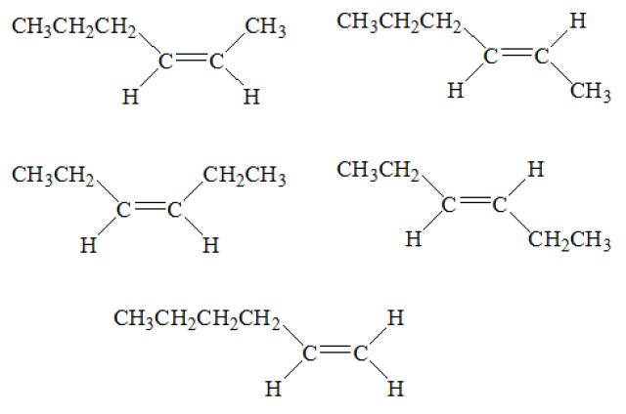

ii

i

iv

iii

1. How many moles of oxygen would be consumed by the complete combustion of 1 mole of Compound (i)?
2. 1 mole
3. 3 moles
4. 9 moles
5. 12 moles
6. Br2 was reacted with each of the compounds. Which reactants would produce the same products as a result of the reaction?
7. i and iii
8. ii and iii
9. iii and iv
10. ii and iv
11. An aqueous solution of butanoic acid can react with:
12. magnesium to produce a solution of magnesium butanoate and hydrogen gas
13. solid potassium carbonate to produce a solution of potassium butanoate, carbon dioxide gas and water
14. sodium hydroxide solution to produce a solution of sodium butanoate and water
15. acidified propan-1-ol to produce butyl propanoate and water

Which of the above statements is true?

1. I and IV only
2. II and IV only
3. I, II and III only
4. I, II, III and IV

**Section Two: Short Answer**

**Question 11** **(3 marks)**

* 1. Define the term ‘functional group’. (1 mark)

* 1. Complete the table by naming the functional groups labelled A-D. (2 marks)

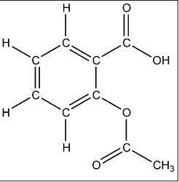

**(A)**

**(B)**

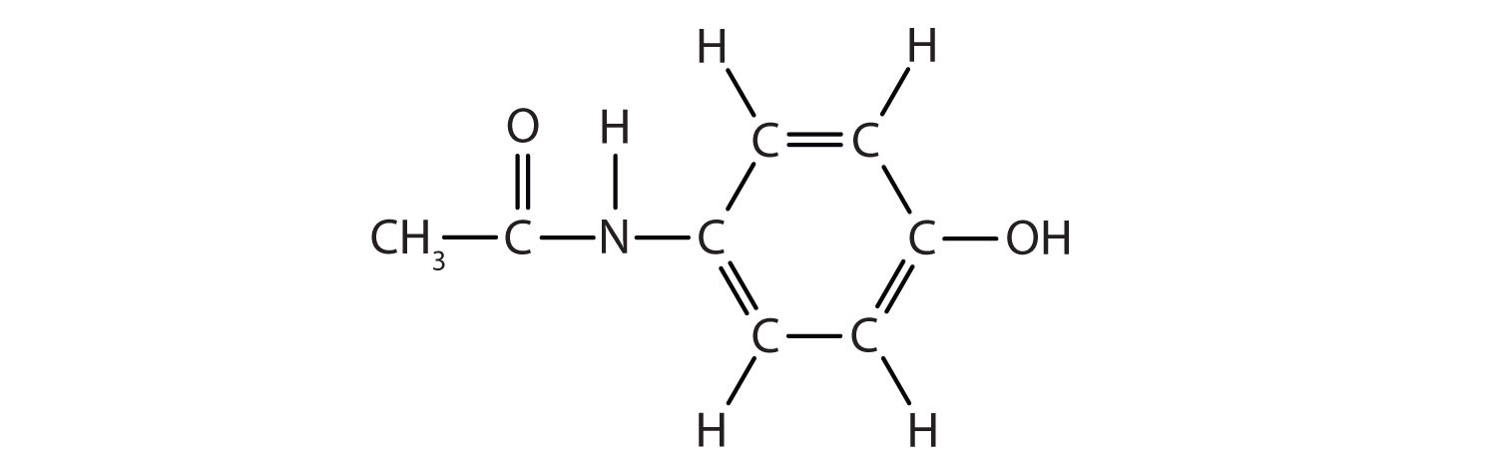

**(C)**

**(D)**

|  |  |
| --- | --- |
| **Label on diagram** | **Name of functional group** |
| A |  |
| B |  |
| C |  |
| D |  |

**Question 12** **(6 marks)**

Complete the following table.

|  |  |
| --- | --- |
| **Name** | **Structural formula (showing all atoms)** |
| *cis*-but-2-ene |  |
|  |  |
| 4-methylpentan-2-ol |  |
|  | http://50.19.212.204/resources/models360/files/31272/butyl_acetate-lewis2.png |
| 2-iodobutanoic acid |  |
|  |  |

**Question 13** **(5 marks)**

Use structural formulae to show the organic product(s) of the following reactions. Show all bonds around functional groups clearly. e.g. write 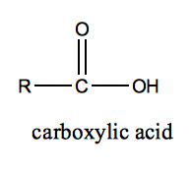 instead of -COOH.

If no reaction occurs, state this clearly.

|  |  |
| --- | --- |
| **Reactants** | **Structure of organic product(s)** |
| CH3CH=CHCH3 + H2O |  |
| H+  OH  CH3CHCH2CH2CH3 + KMnO4 |  |
| CH3OH + CH3COOH → |  |
| CH2=CHCHO + Cℓ2(g) |  |
| CH3CH2CH2NH2 +HCl → |  |

**Question 14** **(9 marks)**

Propane, propanal and propanoic acid all contain the same number of carbon atoms but display different physical properties. Their boiling points are given in the table below.

|  |  |
| --- | --- |
| **Organic compound** | **Boiling point (°C)** |
| propane | -42 |
| propanal | 49 |
| propanoic acid | 141 |

* 1. Account for the difference in boiling points of the three compounds. (5 marks)

* 1. Which of these compounds would be expected to be most soluble in water? Give reasons for your choice. (2 marks)

* 1. Would the expected boiling point of butan-1-ol be greater or less than 92.7 °C (the boiling point of propan-1-ol)? Give reasons. (2 marks)

**Question 15** **(10 marks)**

Two different compounds *A* and *B* are isomers with the molecular formula C3H8O.

*A* and *B* undergo a series of reactions as shown below.

*A*

C3H8O

*C*

C3H6O2

*D*

C3H5O2Na

acidified K2Cr2O7

added dropwise

1. NaOH added

2. solution evaporated

*B*

C3H8O

*E*

C3H6O

acidified K2Cr2O7

added dropwise

* 1. Give the structural formulas for C and E. (2 marks)

|  |  |
| --- | --- |
| Structural formula of C | Structural formula of E |

* 1. How is compound *A* different from compound *B*? (1 mark)

* 1. Describe the colour change observed when acidified K2Cr2O7 is added to *A*. (1 mark)

* 1. Write half-equations to show the reaction that forms compound *C*. Label which half-equation is oxidation and which half-equation is reduction. (4 marks)

|  |  |
| --- | --- |
| **…………………..**  **half-equation** |  |
| **…………………..**  **half-equation** |  |

*B* and *C* can react together in the presence of a small amount of concentrated sulfuric acid to produce *F*.

* 1. Name the type of reaction that occurs between *B* and *C* to from *F*. (1 mark)

* 1. Draw the structural formula of *F*. (1 mark)

**Question 16** **(8 marks)**

Three different organic compounds were each tested with two reagents:

* acidified sodium permanganate solution and
* acidified propanoic acid

Each organic compound has a molecular formula containing five carbon atoms, one oxygen atom and a number of hydrogen atoms.

The observations made are summarised in the following table.

|  |  |  |
| --- | --- | --- |
| **Unknown organic compound** | **Reagent added** | |
| **acidified  sodium permanganate solution** | **acidified  propanoic acid** |
| 1 | no observable change | fruity smell |
| 2 | purple solution decolourises | non observable change |
| 3 | non observable change | non observable change |

1. Complete the table below, identifying the:

* functional group responsible for the observations made
* organic compound, by drawing its structural formula **or** giving its name.

(6 marks)

|  |  |  |
| --- | --- | --- |
| **Unknown organic compound** | **Functional group** | **Structural formula or name of the organic compound** |
| 1 |  |  |
| 2 |  |  |
| 3 |  |  |

1. Draw the structural formula, showing all atoms of the organic product of the reactions of Compound 1 and Compound 2.
2. Organic Compound 1 with the acidified propanoic acid (1 mark)
3. Organic Compound 2 with the acidified sodium permanganate solution (1 mark)

**SPARE PAGE**